DB - Assignment # 2 – Solution

Questions 1:

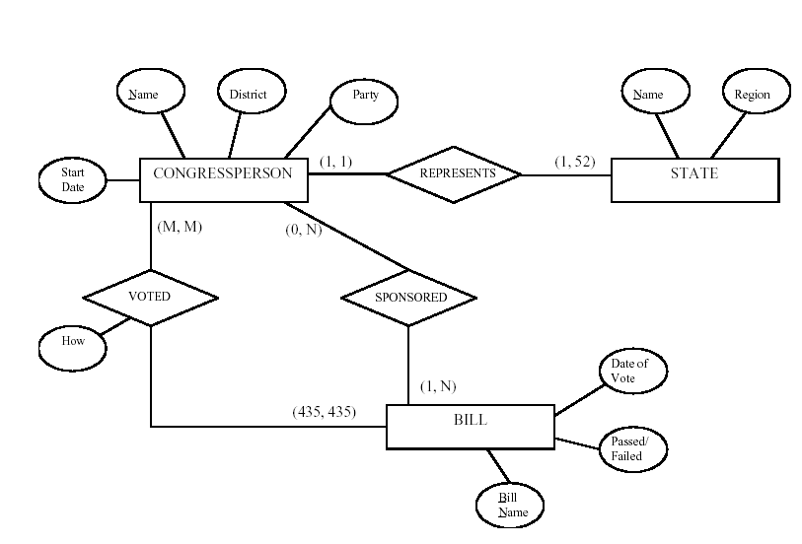

Question 2:

The following design may be used for a baseball league. Here, we assumed that each game in the schedule is identified by a unique Game#, and a game is also identified uniquely by the combination of Date, starting Time, and Field where it is played. The Performance attribute of PARTICIPATE is used to store information on the individual performance of each player in a game. This attribute can be designed to keep the information needed for statistics, and may be quite complex. One possible design for the Performance attribute may be the following (using the notation of Figure 7.8):

Performance( {Hitting(AtBat#, Inning#, HitType, Runs, RunsBattedIn, StolenBases)},

{Pitching(Inning#, Hits, Runs, EarnedRuns, StrikeOuts, Walks, Outs,

Balks, WildPitches)},

{Defense(Inning#, {FieldingRecord(Position, PutOuts, Assists, Errors)})} )

Here, performance is a composite attribute made up of three multivalued components:

Hitting, Pitching, and Defense. Hitting has a value for each AtBat of a player, and records the HitType (suitable coded; for example, 1 for single, 2 for double, 3 for triple, 4 for home run, 0 for walk, -1 for strikeout, -2 for fly out, ...) and other information concerning the AtBat. Pitching has a value for each inning during which the player pitched. Defense has a value for each inning a player played a fielding position. We can have a less detailed or a more detailed design for the performance of a player in each game, depending on how much information we need to keep in the database. Suitable variations of the ER diagram shown below can be used for other sports.

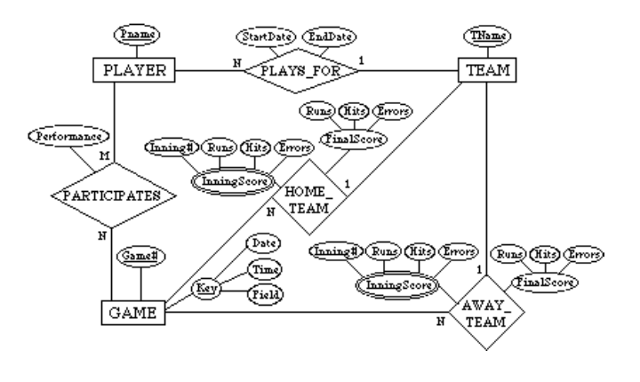

Question # 3:

(a) Entity types: BANK, ACCOUNT, CUSTOMER, LOAN

(b) Weak entity type: BANK-BRANCH. Partial key: BranchNo.

Identifying relationship: BRANCHES.

(c) The partial key BranchNo in BANK-BRANCH specifies that the same BranchNo value ay occur under different BANKs. The identifying relationship BRANCHES specifies that

BranchNo values are uniquely assigned for those BANK-BRANCH entities that are related to the same BANK entity. Hence, the combination of BANK Code and BranchNo together constitute a full identifier for a BANK-BRANCH.

(d) Relationship Types: BRANCHES, ACCTS, LOANS, A-C, L-C. The (min, max) constraints are shown below.

(e) The requirements may be stated as follows: Each BANK has a unique Code, as well as a

Name and Address. Each BANK is related to one or more BANK-BRANCHes, and the

BranhNo is unique among each set of BANK-BRANCHes that are related to the same BANK.

Each BANK-BRANCH has an Address. Each BANK-BRANCH has zero or more LOANS and zero or more ACCTS. Each ACCOUNT has an AcctNo (unique), Balance, and Type and is related to exactly one BANK-BRANCH and to at least one CUSTOMER. Each LOAN has a LoanNo (unique), Amount, and Type and is related to exactly one BANK-BRANCH and to at least one CUSTOMER. Each CUSTOMER has an SSN (unique), Name, Phone, and Address, and is related to zero or more ACCOUNTs and to zero or more LOANs.

(f) The (min, max) constraints would be changed as follows:

